
National University of Sciences & Technology (NUST) Balochistan Campus (NBC), Department of Computer Science
Department of Computer Science
CS-250: Data Structure and Algorithms Class: BSCS 3rd Semester
Lab 9: Implementation of Quick Sort
Date: 7th December 2024
Time: 9 pm – 11.30 pm
Instructor: Safder Ali

NAME | SAMEER TALREJA
CMS | 457795
DEPARTMENT | BS COMPUTER SCIENCE

CS250: Data Structures and Algorithms Page 1

National University of Sciences & Technology (NUST) Balochistan Campus (NBC), Department of Computer Science
Lab 9: Implementation of Quick Sort
Introduction
In this lab, you will implement quick sort.
Objectives
Objective of this lab is to implement Quick sort.
Tools/Software Requirement
Visual Studio C++
Description
You will implement the pseudo code given in the book "Introduction to Algorithms" by Cormen. The algorithm has been added in the assignment as well.
Helping Material
Lecture slides, text book
Lab Tasks
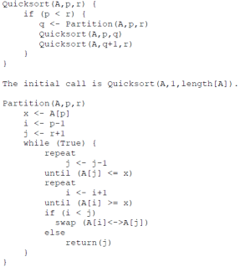
CS250: Data Structures and Algorithms Page 2

National University of Sciences & Technology (NUST) Balochistan Campus (NBC), Department of Computer Science
Task 1:
Implement the quick sort algorithm as per pseudo code give above using C++.
Task 2 (average case complexity):
The next step is to compute the time complexity of the quick sort algorithm. Generate arrays of random numbers in the range 1 to 100 with sizes 100, 1000, 10000, 100000, and 1000000. Compare the running times of the algorithm on each array. Are the results what you expected, and why? Answer the questions in the solution section.
Task 3 (best and worst case complexity):
Now sort the arrays using stl::sort, once in ascending order and then in descending order. Given both sorted arrays as inputs to the algorithm and compute their running time. Plot the running time of the best and worst case complexities for different input sizes in a excel sheet and add it in the solution section.
Important Note: Practice your knowledge of OOP with C++ when creating a solution. Remember to comment your code properly. Inappropriate or no comment may result in deduction of marks.
Solution:
Solution
Task 1:

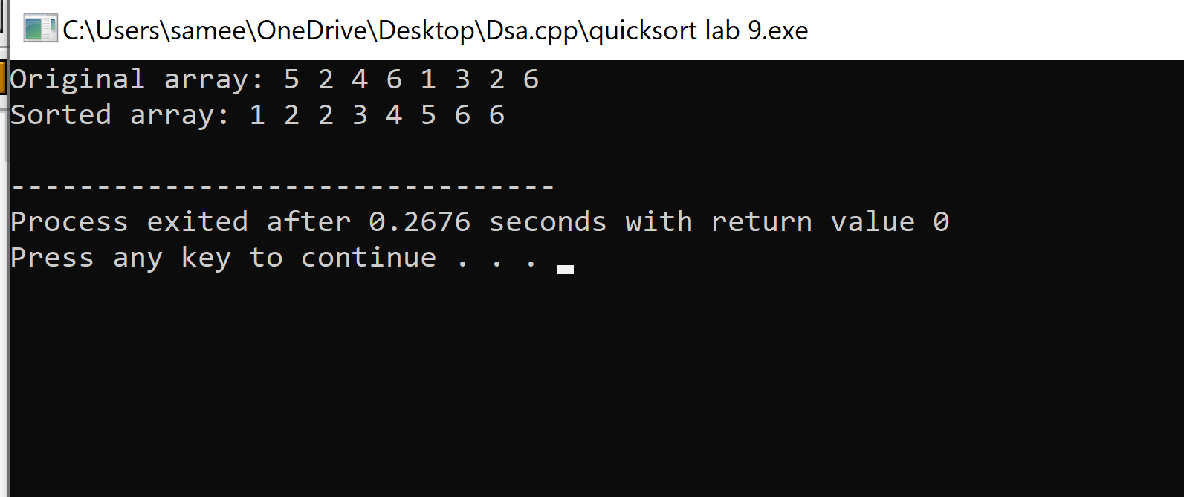

Task 2 :

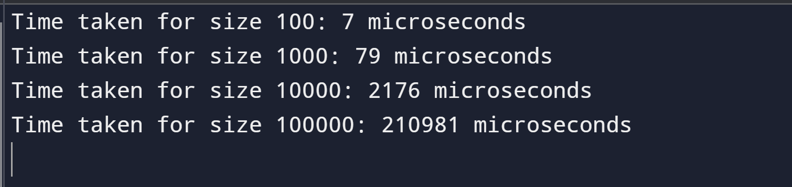

Task 3:

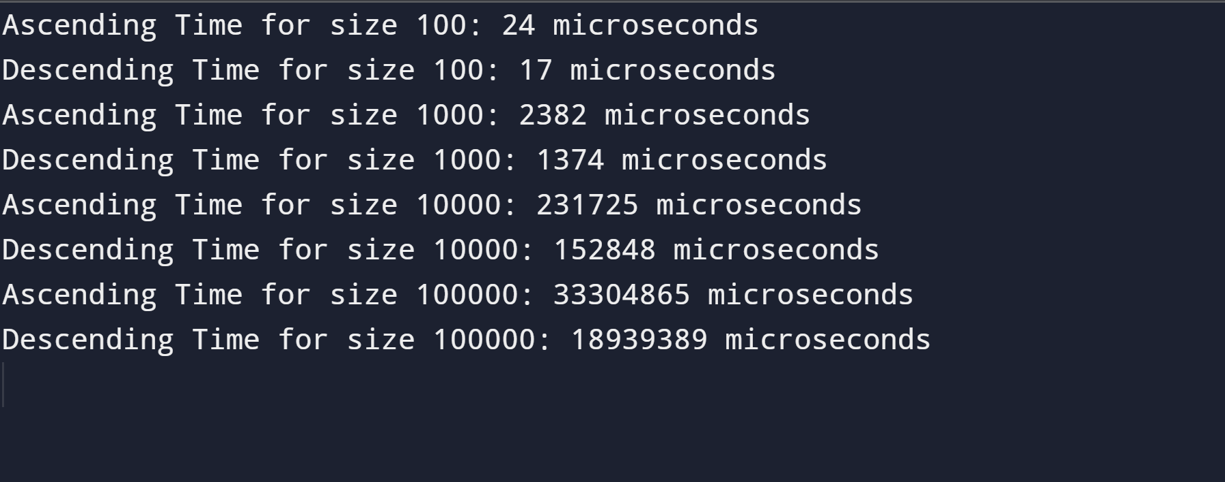

Task 1 Code:

#include <iostream>
using namespace std;

class QuickSort{
public:
// Partition function
int Partition(int A[], int p, int r) {
int x = A[p];
int i = p - 1;
int j = r + 1;
while (true) {
do {
j = j - 1;
} while (A[j] > x);
do {
i = i + 1;
} while (A[i] < x);
if (i < j)
swap(A[i], A[j]);
else
return j;
}
}
// Quicksort function

void Quicksort(int A[], int p, int r) {
if (p < r) {
int q = Partition(A, p, r);
Quicksort(A, p, q);
Quicksort(A, q+1, r);
}
}

};
int main() {
QuickSort sort;
int A[] = {5, 2, 4, 6, 1, 3, 2, 6};
int n = sizeof(A) / sizeof(A[0]);

cout << "Original array: ";
for (int i = 0; i < n; i++) {
cout << A[i] << " ";
}
cout << endl;

sort.Quicksort(A, 0, n - 1);

cout << "Sorted array: ";
for (int i = 0; i < n; i++) {
cout << A[i] << " ";
}
cout << endl;

return 0;
}

Task 2 Code:

#include <iostream>
#include <cstdlib>
#include <ctime>
#include <chrono>

using namespace std;
using namespace std::chrono;

class QuickSort{
public:
// Function to swap two elements
void swap(int* a, int* b) {
int t = *a;
*a = *b;
*b = t;
}

// Function to partition the array
int partition(int arr[], int low, int high) {
int pivot = arr[high];
int i = (low - 1);

for (int j = low; j <= high - 1; j++) {
if (arr[j] < pivot) {
i++;
swap(&arr[i], &arr[j]);
}
}
swap(&arr[i + 1], &arr[high]);
return (i + 1);
}

// QuickSort algorithm
void quickSort(int arr[], int low, int high) {
if (low < high) {
int pi = partition(arr, low, high);

quickSort(arr, low, pi - 1);
quickSort(arr, pi + 1, high);
}
}

// Function to generate random arrays
void fillRandom(int arr[], int n) {
for (int i = 0; i < n; i++) {
arr[i] = rand() % 100 + 1;
}
}
};
int main() {
QuickSort sort;
srand(time(0));
int sizes[] = {100, 1000, 10000, 100000, 1000000};
for (int size : sizes) {
int* arr = new int[size];
sort.fillRandom(arr, size);

auto start = high_resolution_clock::now();
sort. quickSort(arr, 0, size - 1);
auto stop = high_resolution_clock::now();

auto duration = duration_cast<microseconds>(stop - start);
cout << "Time taken for size " << size << ": " << duration.count() << " microseconds" << endl;

delete[] arr;
}
return 0;
}

Task 3 Code:

#include <iostream>
#include <algorithm>
#include <chrono>

using namespace std;
using namespace std::chrono;
class QuickSort{
public:
void swap(int* a, int* b) {
int t = *a;
*a = *b;
*b = t;
}

// Function to partition the array
int partition(int arr[], int low, int high) {
int pivot = arr[high];
int i = (low - 1);

for (int j = low; j <= high - 1; j++) {
if (arr[j] < pivot) {
i++;
swap(&arr[i], &arr[j]);
}
}
swap(&arr[i + 1], &arr[high]);
return (i + 1);
}

// QuickSort algorithm
void quickSort(int arr[], int low, int high) {
if (low < high) {
int pi = partition(arr, low, high);

quickSort(arr, low, pi - 1);
quickSort(arr, pi + 1, high);
}
}

// Function to generate random arrays
void fillRandom(int arr[], int n) {
for (int i = 0; i < n; i++) {
arr[i] = rand() % 100 + 1; // Random numbers between 1 and 100
}
}

// Ascending order
void fillAscending(int arr[], int n) {
for (int i = 0; i < n; i++) {
arr[i] = i + 1;
}
}
// Descending order
void fillDescending(int arr[], int n) {
for (int i = 0; i < n; i++) {
arr[i] = n - i;
}
}
};
int main() {
QuickSort sort;
int sizes[] = {100, 1000, 10000, 100000, 1000000};
for (int size : sizes) {
int* arr = new int[size];

// Ascending order
sort.fillAscending(arr, size);
auto start = high_resolution_clock::now();
sort.quickSort(arr, 0, size - 1);
auto stop = high_resolution_clock::now();
auto durationAsc = duration_cast<microseconds>(stop - start);
cout << "Ascending Time for size " << size << ": " << durationAsc.count() << " microseconds" << endl;

// Descending order
sort.fillDescending(arr, size);
start = high_resolution_clock::now();
sort.quickSort(arr, 0, size - 1);
stop = high_resolution_clock::now();
auto durationDesc = duration_cast<microseconds>(stop - start);
cout << "Descending Time for size " << size << ": " << durationDesc.count() << " microseconds" << endl;

delete[] arr;
}
return 0;
}

CS250: Data Structures and Algorithms Page 3

National University of Sciences & Technology (NUST) Balochistan Campus (NBC), Department of Computer Science
Deliverables
Compile a single word document by filling in the solution part and submit this Word file on LMS. This lab grading policy is as follows: The lab is graded between 0 to 10 marks. The submitted solution can get a maximum of 5 marks. At the end of each lab or in the next lab, there will be a viva related to the tasks. The viva has a weightage of 5 marks. Insert the solution/answer in this document. You must show the implementation of the tasks in the designing tool, along with your complete Word document to get your work graded. You must also submit this Word document on the LMS / google classroom. In case of any problems with submissions on LMS, submit your Lab assignments by emailing it to Safder Ali: students.em96@gmail.com.
CS250: Data Structures and Algorithms Page 4

